Blue Grass Sportsman's League
Skeet Camp
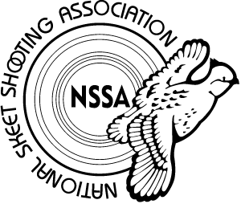

OFFERING YOUTH SKEET INSTRUCTION

The Chief Instructor for National Skeet Shoot Association will be coming to BGSL
When: 3 days- July 5th – 7th 8:00am-4:00pm daily
Who: 12 slots ages 12-18
What: Proper gun mount fit, eye dominance determination, proactive hold points, body position, theory of leads, eye focal point, and mental planning.
The NSSA has granted $1,000 for the cost of targets and ammo. Each student will shoot 22 rounds over the course of three days for the cost of $150
To reserve a spot call 859-858-4458 or email bluegrasshotgun100@gmail.com

